**APIFY – Analysis Report and Technical Approach**

**APIFY Plans:**

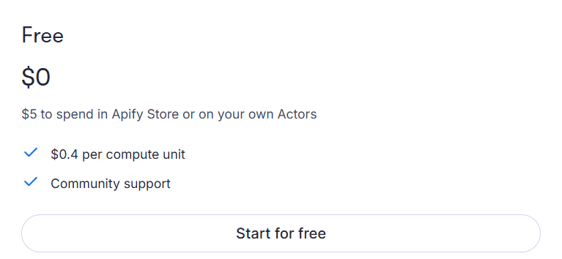

**Approach for Workflow 1 – Leads Finder**

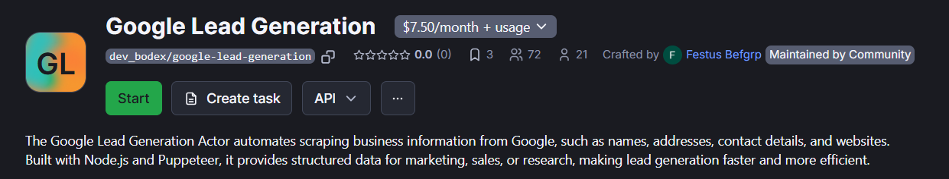

“Google Leads Generation” actor in Apify takes **Keyword, Location** as input and finds some leads from Google search and return the results in a json format with the details given below:

This actor costs **$7.50/month**. The free trial for this actor is 1 day, and this actor is run successfully and it returns similar output as shown above and it returns 539 results/leads, and the number of leads for each keyword are different or ambiguous.

**Note**: The results extracted from this actor are totally different than the results in master sheet. This has a few features of each lead, and outputs only the publicly available information of any organization on Google Business profile of that business.